Attraction | How to get there | Description |  | Opening days |  | Admission Fee | Special event
British Airways London Eye http://www.londoneye.com/  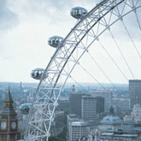  Riverside Building, County Hall  Westminster Bridge Road  The London Eye is situated on the South Bank of the river Thames, opposite the Houses of Parliament. | By tube: approx. five minutes walking distance from Waterloo tube station (follow signs for the South Bank) and Westminster tube station (exit one, follow signs for Westminster pier).  By bus: Buses to the London Eye include the 211, 77 and 381. The London Eye is on most London sightseeing bus tours and on the RV1 route that connects the London Eye to the Tate Modern and Covent Garden.  Time for the visit  30 minutes | A flight on the London Eye, the world's highest observation, is an unrivalled experience. As you rise to an incredible 135 metres above the River Thames, the 30 minute rotation provides stunning panoramic views of the city and reveals parts of London which are simply not visible from the ground. For a truly stunning view, visit at sunset or after dark and see the city awash with colour and famous landmarks floodlit. Each capsule is fully enclosed, air-conditioned and holds up to 25 passengers with bench seating provided. |  | daily except on Christmas Day (25 December) and during its annual maintenance period from 11 to 20 January 2008.  Winter: from October to May :10.00am – 8.00pm daily  Summer: from June to September  June: daily 10.00am - 9.00pm  July – August: Daily:10.00am - 9.30pm  September: Daily 10.00am - 9.00pm |  | Online booking – less expensive  Standard flight:  -Adult (16 plus) - January to March £15.00  -Adult (16 plus) April to December £15.50  -Child (5-15 years) January to March £7.50  -Child (5-15 years) April to December £7.75  -Child under 5 FREE | Champagne flights  Cupid’s Capsule  Wedding on the London eye  Wedding packages  Silver package  Gold package  Platinum package  Birthdays  Civil partnerships  ←  The ticket office is located inside County Hall, which is the building directly next to the London Eye.
Natural History Museum  http://www.nhm.ac.uk/  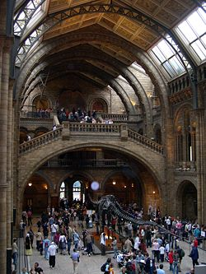  London, Cromwell Road | By tube within walking distance of South Kensington station on the District, Circle and Piccadilly lines  By bus Routes 14, 49, 70, 74, 345, 360, 414 and C1 stop near us. Some tour buses also pass nearby  Time for the visit  At least  2 ½ h | The museum is divided in four Zones:  Red Zone Explore our ever-changing planet. Find out about the massive natural forces that shape it, the treasures we take from it, and what we can do to preserve it.  Green Zone Investigate Earth’s ecology. Meet a dodo. Learn about the meteorites that shaped this planet. All this and more.  Blue Zone Experience the age of dinosaurs, meet the blue whale and discover amazing facts about life, the planet, our environment and evolution.  Orange Zone Explore the Wildlife Garden and see behind the scenes of the Darwin Centre. |  | The Museum is open every day  8.30am - 8.25pm  except 24-26 December. Last admission is at 17:30. |  | FREE | Informative resources designed to enrich visits for children of all ages. Find out about our restless planet, enter the age of dinosaurs, and explore the curious world of creepy crawlies…
British Museum  http://www.britishmuseum.org/  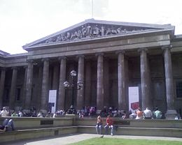  Great Russell street is the main entrance | By bus  Stop near the Museum: 1, 7, 8, 19, 25, 38, 55, 98, 242 - Stop on New Oxford Street: 10, 14, 24, 29, 73, 134, 390  Stop on Tottenham Court Road, northbound and Gower Street, southbound: 59, 68, X68, 91, 168, 188  By underground  Holborn (Central line and Piccadilly line)  Tottenham Court Road (Central line and Northern line – Charing Cross branch)  Russell Square (Piccadilly line)  Goodge Street (Northern line – Charing Cross branch) | It houses a vast collection of antiquities from almost every era and every location throughout history. The mandate of the British Museum is 'to illuminate the histories of cultures for the benefit of present and future generations'. It is famous also for the architecture of the Reading Room surrounded by the Great Court. Most famous among the collections are the Elgin Marbles, the Rosetta Stone, the Benin Bronzes and the Cyrus Cylinder. |  | Daily 10.00–17.30  Selected galleries are open late Thursdays and Fridays  The Museum is closed on 1 January, Good Friday, 24, 25, 26 December  Some galleries may be subject to limited opening times. Check temporary gallery closures for more details. |  | FREE
National Gallery  www.nationalgallery.org.uk  Trafalgar Square  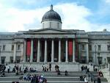 | Underground  Charing Cross: Northern and Bakerloo Lines (nearest to the Getty Entrance).  Leicester Square: Northern and Piccadilly Lines (nearest to the Getty and Education Centre Entrances).  Embankment: Northern, Bakerloo, District and Circle Lines (nearest to the Getty Entrance).  The nearest Underground station with a lift is Westminster on the Jubilee, District and Circle Lines. | The crowning glory of the Trafalgar Square piazza, the National Gallery is a vast space filled to the rafters with Western European paintings. Expect to find works by masters such as Van Gogh, da Vinci, Cézanne, Constable, Caravaggio, Canaletto, Titian and Stubbs. |  | Seven days a week  Opening hours  Daily 10am-6pm  Wednesday 10am-9pm  (Closing commences 5 mins before time stated)  Closed 1 January and 24-26 December. |  | FREE
National Portrait Gallery  www.npg.org.uk  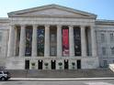 | By underground The nearest underground stations to the Gallery are: Charing Cross 230 metres, Leicester Square 195 metres, and Embankment 490 metres. Please note these stations do not have a lift.  By bus Comprehensive bus routes information is available on the Transport for London's Journey Planner website. | The National Portrait Gallery started life in 1856. It is home to a vast collection of portraits of British men and women. Subjects include great writers such as William Shakespeare and Rudyard Kipling, as well as Kings and Queens and icons of our time. It also has a photographic collection, and boasts one of the best roof-top restaurants in London. |  | Open daily 10am - 6pm  Late night opening Thursday and Friday until 9pm  The Gallery is closed 24-26 December |  | FREE
Tate Britain  http://www.tate.org.uk/britain/  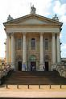  Millbank | Tate Boat runs every forty minutes along the Thames between Tate Modern, the London Eye and Tate Britain.  By Underground  Pimlico (Victoria Line, 600 metres approx.), Vauxhall (Victoria line, 850 metres approx.), Westminster (Jubilee, District and Circle Lines).  By bus  A number of buses service the area, including the 2, 3, C10, 36, 87 (formerly 77A), 88, 159, 185, 436 and 507. | From romantic Pre-Raphaelite paintings to landscapes by Turner and Francis Bacon’s distorted nudes – you’ll find much to gaze in awe at within Tate Britain. If you eat at the gallery’s renowned restaurant, make sure you study the world-famous mural by Rex Whistler between mouthfuls! |  | Open daily 10.00–17.50  Exhibitions open 10.00–17.50  Open until 22.00 on the first Friday of each month for Late at Tate |  | FREE  N.B Most of the exibitions at the Tate Britain and Tate Modern are also free. | ←←←  Tate Britain is located on the north bank of the River Thames at Millbank, south west of the city centre and not far from the Houses of Parliament.
Tate Modern  http://www.tate.org.uk/modern/  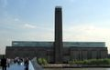 | By underground  Southwark (Jubilee Line) and Blackfriars (District and Circle Lines) are the closest underground stations both of which are approx. ten minutes walk.  By bus  A number of buses service the area, including: RV1 / 45 / 63 / 100 / 381 /  344 / | Sitting Thames-side, London’s great cathedral to international modern art was formerly a power station. Inside Tate Modern you’ll find temporary exhibitions by top artists such as Rachel Whiteread, Frida Kahlo, Martin Kippenberger, Mark Rothko and Kandinsky. And thanks to its riverside setting, the gallery’s restaurants offer fabulous views across the Thames. |  | Open Sunday – Thursday 10.00–18.00  Open Friday and Saturday 10.00–22.00  Last admission into exhibitions 17.15 (Friday and Saturday 21.15) |  | FREE  N.B Most of the exibitions at the Tate Britain and Tate Modern are also free
Buckingham Palace  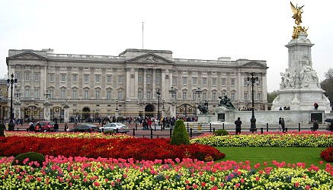 | By underground: Victoria, Green Park and Hyde Park Corner.  By bus: Numbers 11, 211, 239, C1 and C10 stop on Buckingham Palace Road. | Buckingham Palace is one of the most popular landmarks in London. It is the London home of the British Royal family. The 600 room palace is surrounded by a 40 acre garden.  40,000 tulips are planted each year in front of Buckingham palace |  | 31 July - 29 September 2008  09:45 - 18:00 (last admission 15:45) |  | Adult £28.50  Over 60/ Student (with valid ID) £25.00  Under 17 £16.00  Under 5 Free  Family £73.00 (2 adults and 3 under 17s | Summer 2008: Private Guided Tour:  The tours take place at 17:00 on 1, 8, 15, 22, 29 August and 12, 19, 26 September 2008. Tickets must be pre-booked. There is limited availability, with a maximum number of 30 places on each tour.
Westminster Abbey  http://www.westminster-abbey.org/  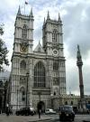 | St James's Park (District and Circle Lines) and Westminster (Jubilee, District & Circle Lines) | Westminster Abbey is one of the oldest buildings in London and one of the most important religious centres in the country. Many kings and Queens and famous people are buried or commemorated there. Its founder, Edward the Confessor, was made a saint after his death and he is buried in a special chapel dedicated to him.  Every King and Queen has been crowned in Westminster Abbey since William the Conqueror in 1066. |  | from Monday to Saturday  Sundays 8.00am - 6.30pm  Weekdays 7.30am - 5.00pm |  | Individuals  Adults £10.00  Concessions (Under 16, students** and 60+) £7.00  Family (x 4) £24.00  **on production of a valid student card. Pre-booked schools Aged 16 to 18 £5.00 | Special services, lectures and seminars, concerts and recitals  Tours and foreign school visits  Tel: +44 (0) 20 7654 4832  Email: tours@westminster-abbey.org
Big Ben  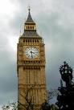 | Nearest underground  St James's Park (District and Circle Lines) and Westminster (Jubilee, District & Circle Lines). | Big Ben is one of the most famous landmarks in the world. The clock tower is situated on the banks of the river Thames and is part of the Palace of Westminster.  Officially "Big Ben" does not refer to the whole clocktower (also known as St Stephen's Tower), but to the huge thirteen ton bell that strikes the hour. |  | Although often referred to as Big Ben, this is actually the nickname of the bell housed within the Clock Tower - and Big Ben's official name is the Great Bell. |  | Tours of the tower are free and open to UK residents who have requested a visit through their local MP. Children under the age of 11 are not permitted. When demand is high those with a proven interest in clocks or bells will be given preference. Tours for overseas visitors are currently not permitted.
Houses of Parliament  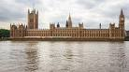 | Nearest underground  St James's Park (District and Circle Lines) and Westminster (Jubilee, District & Circle Lines). | The Palace of Westminster, known also as the Houses of Parliament, is where the two Houses of the Parliament of the United Kingdom (the House of Lords and the House of Commons) conduct their sittings. It is the place where laws governing British life are debated and passed.  The Queen rides in a State coach to Westminster to open each new session of Parliament, usually in the second week in November. |  | It’s open only in summer  July/August: Mon, Tues, Fri, Sat 9.15am-4.30pm, Wednesday and Thursday 1.15-4.30pm.  September: Mon, Fri, Sat 9.15am-4.30pm. Tues, Wed, Thurs 1.15-4.30pm. |  | £12 adults, £30 family ticket (max 2 adults), £8 students and OAPs, £5 children 5-16 yrs, children under 5 go free. | It is possible to attend debates for free:  The galleries are open to the public when the Houses are sitting (meeting), which is from Monday to Thursday and on Sitting Fridays, with differing times for each House. The galleries are not open during recess, when neither House is sitting.
Tower of London  http://www.tower-of-london.com/  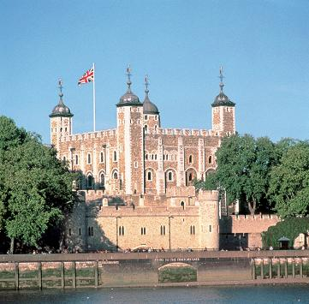 | Nearest Tube: Tower Hill (Circle) London Bridge (Northern, Jubilee,) | The tower of london is a royal fortress, on the north banks of the river Thames.It is the home of the Crown Jewels.  Founded by William the Conqueror in 1066-7 and enlarged and modified by successive sovereigns, today the Tower of London is one of the world's most famous and spectacular fortresses and home to the Crown Jewels Discover its 900-year history as a royal palace and fortress, prison and place of execution, mint, arsenal, menagerie and jewel house. |  | Tuesday - Saturday: 09:00 - 18:00  Sunday - Monday: 10:00 - 18:00  http://www.hrp.org.uk |  | Adult £15.00, Child (5-15) £9.50, Under five FREE, Senior (60+) / Student (with valid card) £12.00, Family (two adults + three children) £43.00
Tower Bridge  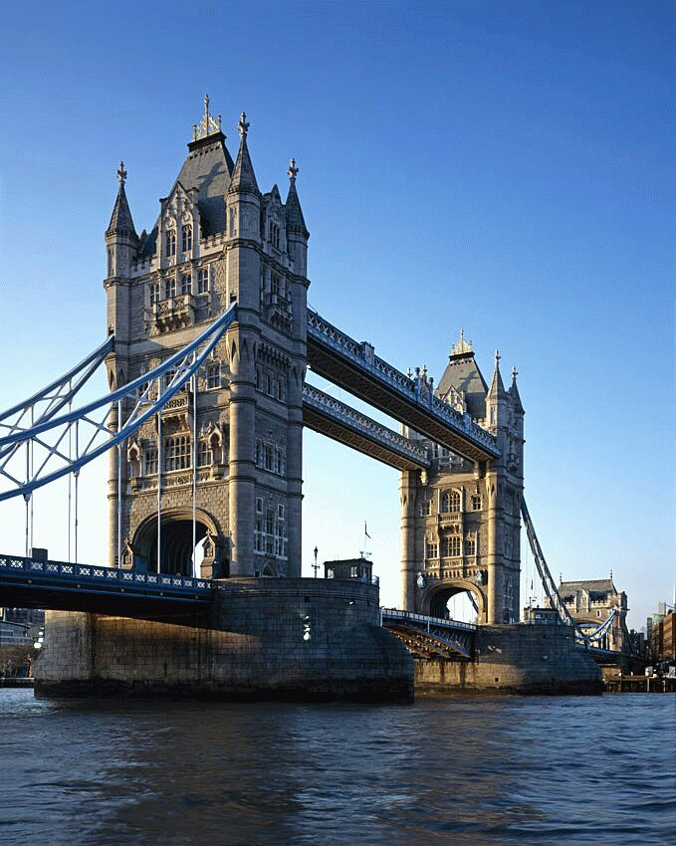 | Nearest Tube: London Bridge | Tower Bridge has stood over the River Thames in London since 1894 and is one of the finest, most recognisable bridges in the World. At the Tower Bridge Exhibition you can enjoy breath-taking views from the high-level walkways and learn about the history of the Bridge and how it was built. You can then visit the Victorian engine rooms, home to the original steam engines that used to power the bridge. |  |  |  | Adult £6.00, Child (5-15) £3.00, Under five FREE, Senior (60 + years) £4.50, Student (with valid card) £4.50.
St. Paul’s Cathedral  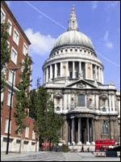 | Underground: St Pauls (Central Line) 5 minutes walk away.  Mansion House, Cannon Street and Blackfriars (for District and Circle Lines) are also close by.  Bus - Numbers 4, 11, 15, 23, 26, 100, 242 and 25 all stop near St. Paul’s. | The first St Paul's Cathedral was built in 604 AD but burnt down in 675. The rebuilt cathedral was again burnt down in the Great Fire of London in 1666.  The present St Paul's Cathedral was built between 1675 and 1711 by Sir Christopher Wren.  The dome of St Pauls Cathedral is the second biggest dome in the world, after St Peter's in Rome. At the dome's base is the Whispering Gallery. A whisper to the wall on one side can be heard on the other. |  | 08.30 to 16.30 Monday to Saturday. Last entry is at 16.00 and last entry to the Galleries is 16.15 |  | Adults £10.00  Students £7.50  Children (7-16yrs)  £3.50  Seniors £9.00
London Dungeons  http://www.thedungeons.com/  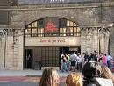 | Nearest Tube: London Bridge | The London Dungeon may be described as a  museum of simulated horror from history,  recalling events of atrocities from the past.  You can journey back to the darker side of  European history. With over forty exhibits it is  not recommended for those of a nervous  disposition or unaccompanied children. The  museum has a wide variety of attractions  including up to date multi media displays. |  | 7 days a week every day of the year except Christmas Day  Approx  10.00 am – 5.00 pm |  | Admission : Adults: £14.50 adults, Children(5-14): £10.45
Harrods www.harrods.com  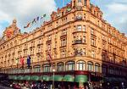 | By Tube  Knightsbridge tube stop on the Piccadilly line, the Brompton Road exit has an exit right out side our doors.  By Bus  9, 10, 14, 19, 22, 52, 74, 137, 414, C1 | It is a big elegant store |  | Main Store: Monday to Saturday - 10am to 8pm  Sunday - 12 noon to 6pm |  | FREE
Shakespeare’s Globe  www.shakespeares-globe.org  email:  info@shakespearesglobe.com  Shakespeare's Globe  21 New Globe Walk  Bankside  London SE1 9DT  Telephone: +44 (0)20 7902 1400  Fax: +44 (0)20 7902 1401  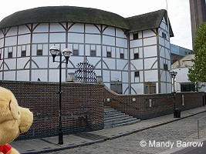 | By underground  The local stations are Mansion House on the District amd Circle Lines (10 minute walk), London  By bus: local routes include:  45, 63, 100 to Blackfriars Bridge  15, 17 to Cannon Street  11, 15, 17, 23, 26, 76 to Mansion | The play’s the thing, as in Tudor days. The replica of the 1599 playhouse opened in 1966 and is worth a visit even if you’re not seeing a play (guided tours every half-hour 9.15am-12.15pm). The Globe has been painstakingly recreated using the original methods of construction. The season of the open-air galleried theatre runs from May to September |  | 6 days a week  From 9 to 4 pm |  | globe tour: 10 £  shows: check the different prices at box office  (box office tel: 7401 9919) | The theatre offers performances for any kind of audience at any time of the day. There is also an educational programme for students and there are stage activities both for adults and children.
Covent Garden  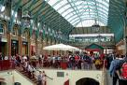 | Tube: Covent Garden | Covent Garden is known for its many open-air cafés, restaurants, pubs, market stalls and shops. Famous are the many street performers who entertain the visitors on the pedestrianized piazza.  A former floral market now houses the Theatre Museum and the London Transport Museum. The Covent Garden district is also home to several theaters and the recently renovated Royal Opera House. |  |  | FREE
Madame Tussauds  http://www.madame-tussauds.co.uk/index.htm  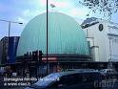  Marylebone Road  tel: +44 (0) 870 999 004 | Tube  Baker Street underground station is on the Bakerloo, Circle, Jubilee, Metropolitan and Hammersmith & City lines, making it a short, easy journey from anywhere on the central London tube network.  Bus  The following bus numbers travel to Madame Tussauds: 13, 18, 27, 30, 74, 82, 113, 139 and 274. | At Madame Tussauds you will experience what it is like to be famous as you join a host of the world’s hottest celebrities with a range of interactive experiences. You can sing, dance and perform with Beyonce, Britney, and Kylie and make J-Lo blush, Or you can give Brad Pitt’s bum a squeeze without him having you escorted off the premises! Have your say on international politics at a press conference and join the Queen for a private audience. | open every day of the year except Christmas Day  Opening Times  Peak (ie all weekends and all school holidays)  9.00am - 6.00pm |  | Adult £23.00, Child (5-15) £20.00, Under five FREE. ChamberLive (12+) an additional £2.00  Save up to 50% on normal ticket price when you book online  after 5pm your tickets can cost as little as £10 for children and £12.50 for adults.
Albert Memorial  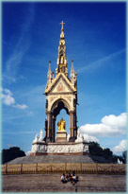 | Tube: Lancaster Gate Station | The Albert Memorial was commissioned by Queen Victoria as a tribute to her late consort, Prince Albert of Saxe-Coburg-Gotha. The high-gothic monument was completed in 1876, 15 years after prince Albert died at the age of 41.
Kensington Palace  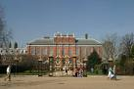 | Tube: HighStreet Kensington | Kensington Palace has been a royal residence since 1689 and part of the palace remains a private residence for members of the Royal Family today. Visitors can explore the magnificent State Apartments and the Royal Ceremonial Dress Collection, which includes dresses worn by Her Majesty Queen Elizabeth II and Diana, Princess of Wales. |  |  | Adult £11.50, Child (5-15) £7.50, Under five FREE, Senior (60 + years) £9.00, Family (up to two adults and three children) £34.00.
Hampton Court  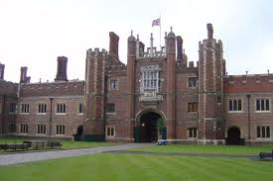 |  | Hampton Court Palace promises a magical journey back through 500 years of royal history. Discover the magnificent State Apartments of Henry VIII and William III and the priceless collection of Royal paintings. Explore 60 acres of immaculate riverside gardens and lose yourself in the world-famous maze. |  |  | Adult £12.30, Child (5-15 years) £8.00, Under five FREE, Senior (60 + years) £10.00, Family (up to two adults and three children) £36.50
London Zoo  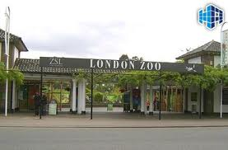 |  | Set in leafy Regent’s Park, London Zoo is the perfect day out for the whole family. Visit the new exhibit 'Into Africa' where you will come eye to eye with some of Africa's most unusual animals including Giraffes, Zebras and African hunting dogs.  You can 'Meet the Monkeys'; an exciting monkey walk-through experience, or enter Butterfly Paradise; where you'll have the chance to enjoy the beauty of butterflies as they fly around you. |  |  | Adult £14.50, Child (3-15) £11.50, Under three FREE.
Canary Wharf Tower  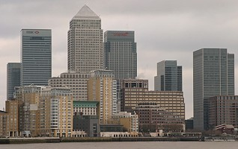 |  | The Tallest building in the UK is in Canary Wharf, part of the London Docklands. One Canada Square, known as the Canary Wharf Tower, is 244 metres high and covered in stainless steel.
Cruise to the Thames Barrier  www.thamesbarrierpark.org.uk  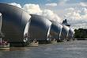 |  | Take a boat from Greenwich to see London’s massive defence against flooding. The giant gates of the £435 million barrier, finished in 1982, can rise to 15ft (4.6 metres) higher than the highest Thames tide, forming a wall of steel against the river’s flow. You can reach the visitor centre on the south side by boat or bus from Greenwich |  |  | (open 10am-4pm weekdays, 10.30-4.30pm weekends; tel; 8305 4188; admission fee ???).
The Millenium Dome  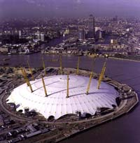 |  | The Millennium Dome in London is the largest dome in the world, covering over 180 acres; it is 320m in diameter and 50m high with support towers reaching 100m. It can accomodate Nelson's Column standing upright and the Eiffel Tower placed horizontally.  It was built on the Greenwich Meridian (0 degrees longitude) to commemorate the new millennium.

